# For loop in C++

Task 01:

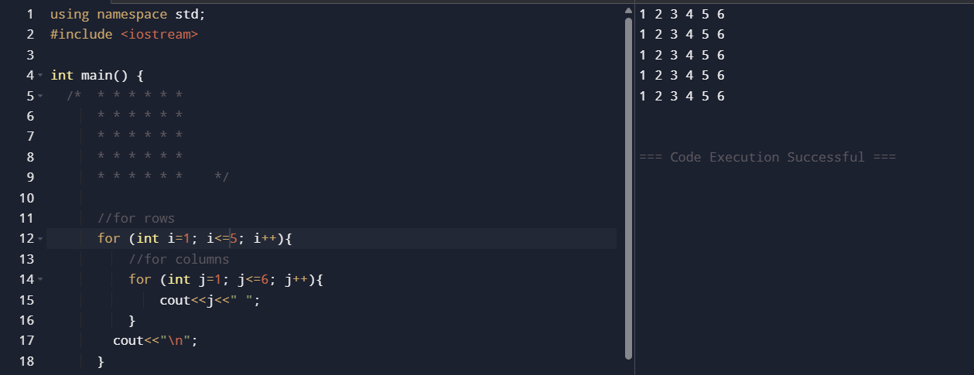

Task 02:

Task 03:

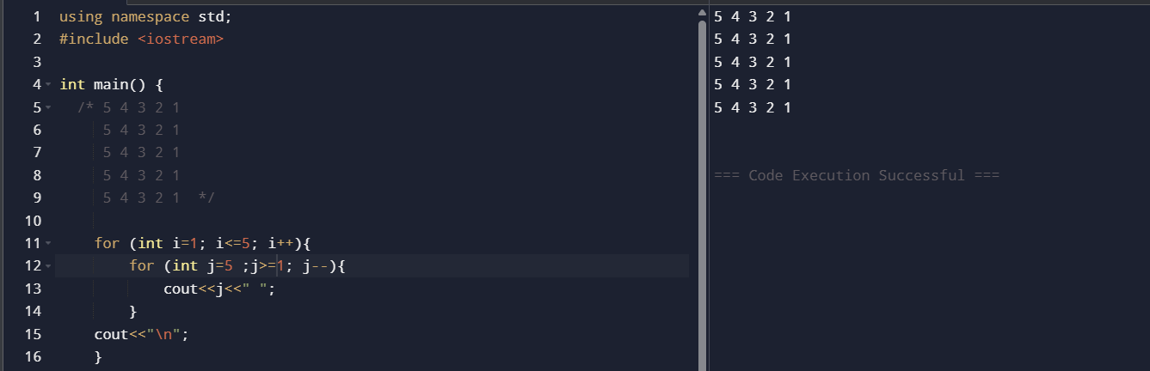

Task 04:

Task 05:

Task 06:

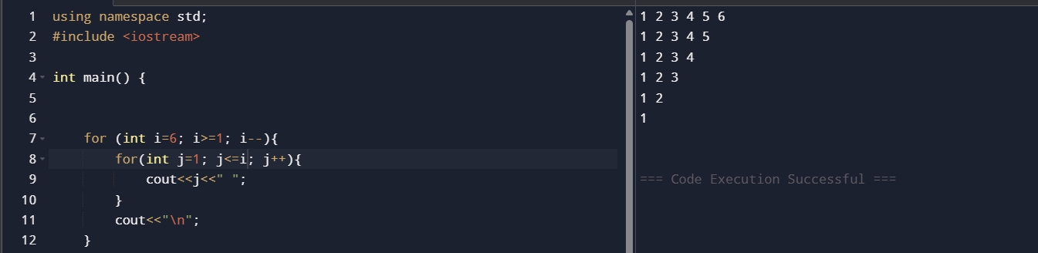

Task 07:

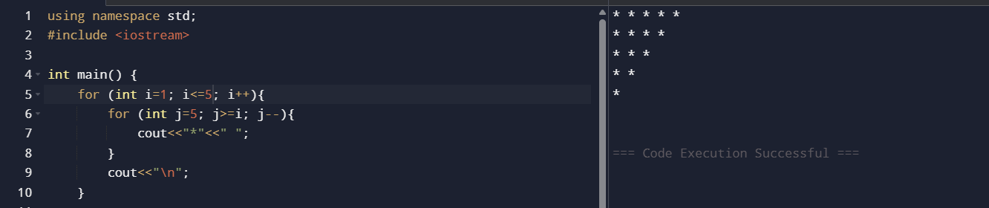

Task 08:

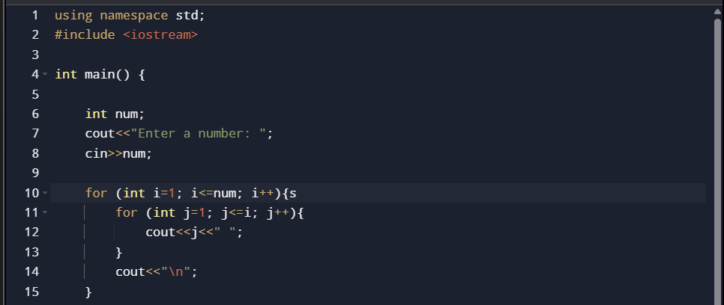

Task 09:

Task 10:

Task 11:

Task 12: